Instructions for Use

[Description]
The T-Gen(Absorbable collagen membrane) is made of purified collagen without further cross-linking or chemical treatment. The collagen is extracted from veterinary certified pigs and is carefully purified to avoid antigenic reactions. The T-Gen is a collagen membrane obtained by porcine pericardium in a standardized, controlled manufacturing process. The T-Gen has a porous and fibrous microstructure that prevents the ingrowth of fibrous tissue into the bone defect.
The T-Gen is packed by a packaging material composed of a transparent side and an aluminium side and is easy to use by open system of easy peel type. It is easy to check the T-Gen, because one side of packaging is transparent closed by double packing system in order to protect T-Gen from microbial formation and moisture penetration. Then this packaged T-Gen is sterilized by gamma irradiation. The packaging contains the T-Gen and one Template for Tyvek material.
The T-Gen is available in 5 sizes as shown below. They are supplied sterile and intended for single use only.

Model No. | Size | Packaging (ea/box) | Collagen membrane weight | Collagen Content type1
TG-1 | 15 mm x 20 mm | 1 membrane / 1 template | 4-10mg/cm² | ≥80%
TG-2 | 20 mm x 30 mm | 1 membrane / 1 template | 4-10mg/cm² | ≥80%
TG-3 | 30 mm x 40 mm | 1 membrane / 1 template | 4-10mg/cm² | ≥80%
[Mode of action]
T-Gen functions as a barrier when applied between bone graft material and soft tissue. The membrane serves as a bioresorbable scaffold that is eventually resorbed and replaced by host tissue. T-Gen is substantially absorbed within 24 weeks after implantation.
[Indications for use]
T-Gen is recommended for:
- Simultaneous use of GBR-membrane (T-Gen) and implants;
- Augmentation around implants placed in immediate extraction sockets;
- Augmentation around implants placed in delayed extraction sockets;
- Localized ridge augmentation for later implantation;
- Alveolar ridge reconstruction for prosthetic treatment;
- Aid regeneration of bone defects after root resection, cystectomy, removal of retained teeth;
- Guided bone regeneration in dehiscence defects

[Direction for use or procedure]
1) Preparation of surgical site
- The wound site of patient should rinse with antimicrobial agent or sterilized saline solution.
- The bone defect is exposed by a mucoperiosteal flap and basic surgical procedures (e.g., curettage) are undertaken.
- The bone defect is filled with a space-making material, autologous bone or bone grafting material, whenever possible. The defect should not be overfilled.

2) Instructions for use
- Peel outer pouch, choose T-Gen to fit the wound area and trim it to fit the size of the defect. T-Gen should overlap walls of the defect by at least 2 mm to allow complete bone contact and to prevent connective tissue ingrowth lateral to the material.
- The template is a convenience item to assist in shaping the T-Gen and not implantable, which is must be discarded following modification. In order to distinguish between the membrane and the template, the template is marked with the word “TEMPLATE”.
- The T-Gen can be used regardless of front and back side.
- The T-Gen can be used in dry or hydrated conditions. If the clinician prefers the handling state of the hydrated condition, the membrane can be hydrated in sterile water or sterilized saline solution for at least 3 minute prior to use.
- The T-Gen is applied over the defect and held in place with moderate pressure. Adhesion to the bone surface is facilitated by the hydrophilic properties of the membrane.
- Fixation of the T-Gen is possible due to its high tensile strength. Fixation may be indicated to avoid membrane displacement due to shear loading or mobilization.
- The mucoperiosteal flap is sutured over the membrane securely and without tension. In general, the wound should be closed completely to avoid possible accelerated absorption of the exposed membrane.

3) Postoperative patient care
- After the operation, wound site must be treated carefully in order not to be pressured and should be managed in accordance with a prescription of a surgeon.
- The T-Gen is fully resorbable and should not be removed.

[Contraindications]
(1) T-Gen is derived from a porcine source and should not be used in patients with known sensitivity to porcine material.
(2) T-Gen is not be used in patients with a known collagen allergy.
(3) T-Gen should not be used in the presence of infected wounds.
(4) T-Gen should not be used in patients suffering from autoimmune disease and connective tissue disease, such as: systemic lupus erythematosus, dermatomyositis etc.

[Precautions]
(1) Device is sterile if the package is unopened and undamaged. Do not use if the package seal is broken.
(2) Do not re-sterilize. Discard all open and unused portions of T-Gen.
(3) The device must be used prior to the expiration date.
(4) Discard device if mishandling has caused possible damage or contamination.
(5) Do not reuse. Sterility and function no longer guaranteed in the event of reuse. Cross contamination and infection may occur if reused.
(6) T-Gen should only be used by trained dentists and surgeons.
(7) T-Gen should be used with special caution in patients with acute or chronic infection at the surgical site, uncontrolled metabolic diseases, prolonged corticosteroid therapy, autoimmune diseases, radiotherapy and heavy smoking.
(8) If there are any changes in the performance of the membrane (such as infection, pain, any other unusual symptoms), clinician has the responsibility to inform the patient on all proper contraindications, side effects, and precautions. When these conditions occur, clinician should be instructed to see a well trained dental specialist immediately.
(9) Effects on pediatric patients is not known.
(10) Effects on women who are pregnant or breastfeeding is not known.

[Warnings]
(1) In using the T-Gen, it must be complied with the general principle of sterile handling and patient medication.
(2) Due to the adherence to the bone tissue and the elasticity of T-Gen, the use of bone augmentation material is recommended to create and maintain space for bone regeneration.
(3) In the case of membrane exposure during the healing phase the resorption time may be accelerated.

[Adverse Reactions]
(1) As T-Gen is a collagen product, in very rare cases allergic reactions may occur.
(2) Due to the special physical properties and the prolonged absorption time, an inflammatory reaction may occur in rare cases.
(3) Possible complications which may occur with any surgery include swelling at the surgical site, flap sloughing, bleeding, dehiscence, hematoma, increased sensitivity and pain, bone loss, redness, local inflammation and complications due to the use of anaesthetics.

[Interactions with Other Medicinal Products and methods]
(1) The effectiveness of T-Gen can be reduced by aggregation inhibitors and anticoagulants, since they might impair the creation of the blood coagulum under the membrane.
(2) No interactions in magnetic resonance imaging are known, neither are they to be expected in view of the biochemical composition of the T-Gen.

[Storage Conditions]
(1) Store at use only between 1 and 30℃.
(2) Keep away from heat.
(3) Keep dry.

[Disposal]
The product can be disposed of with normal clinical waste, but local regulations must also be observed.

[Information]
1. In the event of side effects and incidents caused by the product, user should be inform the Importer and/or Distributor immediately.
2. The implant card enclosed in the box contains information about the manufacturer and the implanted device. Fill in the implant card with information about the medical institution and device identification and deliver it to the patient.(The information about identification of the device to need to fill in the Implant card, refer to the enclosed patient label.)

[Symbols on the Label]
 | Authorized representative in the European Community
 | CE mark and identification number of Notified Body
 | Do not re-use
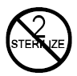 | Do not resterilize
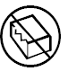 | Do not use if package is damaged
 | Consult instructions for use
 | Manufacturer
 | Sterilized using irradiation
 | Temperature limit
 | Batch code
 | Use-by date
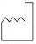 | Date of manufacture
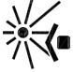 | Keep away from sunlight
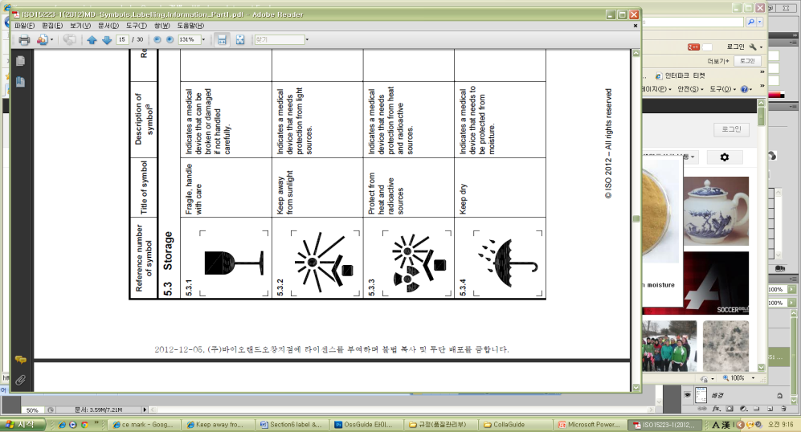 | Keep dry
 | Patient Name or patient ID
 | Date of implantation
Name and Address of the implanting healthcare
institution/provider
 | Information website for patients
 | Device Name
 | UDI as AIDC format

Emergo Europe
Prinsessegracht 20, 2514 AP The Hague, The Netherlands

SK bioland Co., Ltd.
162, Gwahaksaneop 3-ro, Ochang-eup, Cheongwon-gu, Cheongju-si,
Chungcheongbuk-do, 28125, Republic of Korea
Tel. +43-240-8633, 8636 Fax. +43-240-8699
www.skbioland.com

